|  |  |  |  |  |  |  |
| --- | --- | --- | --- | --- | --- | --- |
| Event No | Time | Management (organization) | Officers(human) | Crew(Human) | Vessel(Technical) | Contributory factors |
| E1 | 3 days delay  0500 on 15 December to 2300 on 18 December | Burke Agencies  Pressure to enter port for minimizing demurrage |  |  |  | Due to delay of unloading in the earlier ships |
| E2 | 1415 |  |  | Neither the bridge team nor the pilot received the weather forecast by Clyde coastguard |  | Did not changed the channel to VHF |
| E3 | 14.30 on 18 December |  |  | Pilot compromised without day light |  | Pilot did not want to navigate the ship up river on Wednesday 02.30 to 07.00  Fog forecasted early morning |
| E4 |  |  |  | Pilot considered three tugs are sufficient |  | Did not follow the pilotage directions and guidelines |
| E5 |  |  | Harbourmaster Could not able to provide second pilot |  |  | Due to unavailability |
| E6 | 1600 |  |  | Pilot not received sufficient weather report |  | He only received wind and tide information.  He has not received any due information |
| E7 |  |  | Deputy Harbourmaster has not recived information about fog |  |  | Erskine bridge operator does not have able to predict weather forecast |
| E8 | 1717 |  |  | Pilot reported his position wrongly |  | Pilot reported as he was at Dunglass instead of Esso Bowling Jetty |
| E9 | 1719 |  |  | Pilot come to know the fog |  | Overheard the report made by Yoker Swan to Estuary Control |
| E10 | 1750 |  | Svitzer Mallaig’s skipper reported thick fog ahead |  |  |  |
| E11 | 1753 |  |  | Pilot not able to see Svitzer Mallaig deck light |  | Due to dense fog |
| E12 |  |  |  |  | Red Jasmine not able to turn starboard side in time | Rate of turn was not sufficient |
| E13 |  |  |  | Pilot instructed to Flying Phantom to take the vessel bow to starboard |  | In order to increase rate of turn |
| E14 | 1755 |  |  | Pilot instructed stop pulling and ordered to hard port |  | Due to the earlier command it turns sufficiently.  To study the ship ahead |
| E15 | 1756 |  |  | Dead slow ahead was order to Red Jasmine helms man |  | Flying Phantom and Red Jasmine entered in fog |
| E16 | 1758 |  |  | Pilot ordered Flying Phantom skipper to take the Red Jasmine head to starboard |  | Pilot realized that he could no more able to control with Red Jasmine rudder |
| E17 | 17:58:31 |  |  | Pilot instructed Flying Phantom skipper to bow needed to move further starboard |  | Red Jasmine was not turning sufficiently and heading towards grounding |
| E18 | 17:59:02 |  |  | Pilot instructed to Flying Phantom to ease off |  |  |
| E19 | 17:59:19 |  |  | Pilot instructed crew of Flying Phantom to let go their tow line |  | Mate of Flying Phantom stated grounded |
| E20 | 18:00:35 |  |  | Flying Phantom grounded |  | Towing line is not released in time.  View of Towing winch is not visible – camera system has not operated. |
| E21 |  |  |  | Only the Mate clambered out of the wheel house |  | Expected the rest of the crew will follow him |
| E22 |  |  |  | Community warden raised the alarm |  | Heard the call of mate |
| E23 |  |  |  | Those on shore not able to see the mate |  | Due to thick fog |

Technical:

Emergency release system not operated quickly

Tug is not designed for girting

Fog detectors not available

Engine room doors sill immersed at 30deg heel

Emergency release system is not designed for girting

Tugs bride equipment – well positioned to assist them in blind operations

Crew / Operator / Human error:

Routine observation prior to tow- ineffective

Port side Engine room door opened. This is reduced the range of stability

Mate was expecting others will follow him

Lack of situation awareness

Organization:

Svitzer Marine Ltd:

No operation limits in tug operations -restricted visibility

No procedures - restricted visibility

Clyde Port:

Risk assessment poor

Inadequate controls in thick fog

Quality management systems –flawed

Fog detection system not purchased

UK ports:

not improved controls due to earlier accidents

Classification / Statutory bodies:

Lack of standards for towing winch emergency release system

Training- blind pilotage operations

Visibility : refer page 165

Fault tree : Refer 195

FSA : Formal safety assessment : refer 283

Accident Analysis:

Performance shaping factors : The following parameters are influencing on the performance of crew in navigation of ship in the channel. The reliability of the crew/ pilot is depends on the PSF. Those are listed below:

Available time

Experience and Training in fog

Stress and Stressors

Task complexity

Situation awareness

Ergonomics (Human machine interaction)

Environmental factors

Procedures and Guidelines

Insufficient information about vessel position in fog

Insufficient information about fog

Changing the ship (Tug crew)

Step Diagram: refer 372

What is a Scenario?

The scenario could be based on known accidents or incidents. The scenarios should be selected on the basis of the following criteria:

• The scenarios should be realistic. It should cover all the parties involved in the accident.

• It should have a potential of major losses.

STEP (Sequentially Timed Events Plotting diagram) diagram has a proven method for describing the accidental scenario. A STEP diagram illustrates the actors and events in a time-line diagram. STEP diagram for Flying Phantom has included below. This methodology can be used for STEP improved communication and understanding situation. The Scenario Analysis addresses alternative sequences, i.e. “what could have happened if “..

ysr_phy@rediffmail.com

Flow charts of events: refer 375

<http://www.sciencedirect.com/science?_ob=ArticleListURL&_method=list&_ArticleListID=927853783&_sort=d&view=c&_acct=C000030078&_version=1&_urlVersion=0&_userid=586462&md5=59256ec3a8900d55d37219c21bb930c5>

Fishbone diagram:

* Also known as cause-effect-diagrams
* Developed by Ishikawa in the early 1950s (Kawasaki Company)
* The method consists of defining an occurence of a typically undesirable event or problem (fish head)
* Identifying contributing factors “causes” or fish bones

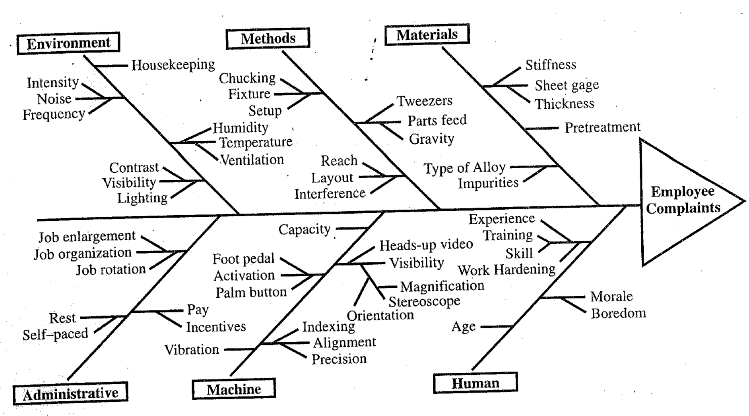

Investigation technique:

**Fault Tree Analysis (FTA):**

Fault Tree Analysis (FTA) is a logic diagram showing all the potential causes of an accident or other undesired event. FTA involves these steps:

1. Define the undesired event to study.

2. Obtain an understanding of the system.

3. Construct the fault tree.

4. Evaluate the fault tree.

5. Control the hazards identified.

This information determines the most probable sequence of events leading to the accident.

Another investigation technique would be a Job Safety Analysis (JSA). A JSA is based on the following steps:

1. Select the job to be analyzed.

2. Separate the job into its basic steps.

3. Identify the hazards associated with each step.

4. Control each hazard.